Trust of News, Information and Users in the Digital Age

#smtrust

This workshop will begin a discussion about news and democracy in the digital age. A quick review of a report from Public Policy Forum serves as a spark for coordinated group brainstorming around research and policy needs. Focus will then turn to debate over studies that address aspects of these concerns, beginning with a cross-national online survey of Internet users and how they use search and social media to access information about politics. The discussion will then turn to a related study looks at how individuals access and learn from news on social media. These studies will be discussed individually and together – over Twitter (at #smtrust) and in the workshop – before turning to issues for policy and practice in Canada and worldwide, such as around social media, search, and digital media literacy. Breakout groups will formulate proposals for policy and practice that will be presented to the workshop in a final discussion section.

Part 1. Threats to the Future of News: a Canadian Perspective

Elizabeth Dubois and Ed Greenspon

Canada’s Public Policy Forum produced a 2017 report, entitled ‘The Shattered Mirror’, which details the future of news and related policy in Canada. The report raises a number of major issues concerning news, democracy and trust in the digital age and provides a list of broad policy recommendations. This seems like an excellent place to begin our workshop: What are the major concerns over news and information in the digital age?

Participants will participate in guided small group discussion on key questions the report brings to light such as: What academic research is needed to further policy objectives? How might we implement Creative Commons licensing for the CBC? What should/could the government do to counter “fake news”? And are these the right priorities?

This early discussion will help set the tone for the rest of the workshop and encourage participants to share their own experiences as each project is presented.

References

Public Policy Forum, ‘The Shattered Mirror: News, Democracy and Trust in the Digital Age’, Ottawa, ON, Canada: Public Policy Forum. Available online at https://shatteredmirror.ca

Part 2. Search and Politics: Fake News, Filter Bubbles, and Echo Chambers

William Dutton, Elizabeth Dubois, and Craig Robertson

Global debate over the impact of algorithms and search on shaping political opinions has increased following 2016 election results in Europe and the US. Powerful images of the Internet enabling access to a global treasure trove of information have shifted to worries over whether those who use search engines and social media are being fed inaccurate, false, or politically targeted information that distorts public opinion. There are serious questions over whether biases embedded in the algorithms that drive search engines and social media have major political consequences, such as creating filter bubbles or echo chambers. For example, do search engines and social media provide people with information that aligns with their beliefs and opinions or do they challenge them to consider countervailing perspectives? Most generally, the predominant concern is do these media have a major impact on public opinion and political viewpoints, and if so, for the better or worse.

This study addresses these issues by asking Internet users how they use search, social media, and other important media to get information about political candidates, issues, and politics generally, as well as what difference it makes for individuals participating in democratic processes. We conducted an online survey of Internet users in seven nations: Britain, France, Germany, Italy, Poland, Spain, and the US. Discussion will focus on whether this research can be used to identify those most vulnerable to fake news or bias in access, and what can be done to support them, ranging from media reform to digital media literacy.

References

Dutton, W. H. (2017), ‘Fake News, Echo Chambers and Filter Bubbles’, The Conversation, available online at: https://theconversation.com/fake-news-echo-chambers-and-filter-bubbles-underresearched-and-overhyped-76688

Dutton, W.H., Reisdorf, B. C., Dubois, E., Blank, G., Ahmad, S., and Robertson, C. (2017), ‘Search and Politics: The Uses and Impacts of Search in Britain, France, Germany, Italy, Poland, Spain, and the United States’, Quello Center Working Paper available online at: https://papers.ssrn.com/sol3/papers.cfm?abstract_id=2960697

Part 3. Processing News

Anne Oeldorf-Hirsch

Internet users are increasingly getting their news from social media, and they are also doing so more passively. Given the growing “news-finds-me” perception on social media, questions arise about how social media users assess the credibility of news content and what they learn from it. A collection of studies shows that while social media users actively engage with news content on social media platforms, this does not translate to greater knowledge about current events. Furthermore, users may not differentiate between sources when judging the credibility of news content.

The primary study discussed in this workshop is built on this work and experimentally tests how Facebook users assess and learn from news content in Facebook news posts where multiple media and friend sources must be considered. The results show that source effects on credibility as well as learning depend heavily on a user’s involvement in the content.

Discussion of this research will focus on the implications of this growing body of research that shows a lack of beneficial effects of social media news exposure on knowledge. Participants will share their own social media experience and expertise to brainstorm and compile a shareable guide on: 1) what user and technology elements may contribute to the disconnect between social media use and current events understanding, 2) what role social media should have in one’s engagement with current events, and 3) what actions users can take to use these media more meaningfully for their news consumption.
Reference

Oeldorf-Hirsch, A., & DeVoss, C. (2017, May). Processing layered news sources on Facebook: Effects on credibility and learning. Presented at the 67th annual conference of the International Communication Association (ICA), San Diego, CA.

Part 4. Directions for Research, Policy, and Practice

Ed Greenspon

In the final segment of this workshop we return to our initial brainstorming groups to review the day’s insights in terms of next steps for research and policy. We then discuss broad questions as a group.

Some guiding questions include: What are the missing pieces in our understanding of the dynamics of individual and collective exposure to news and information about politics? What are the priorities for research? What are the major implications for policy and practice? Is panic over contemporary issues leading to inappropriate initiatives for governance, policy and practice? Are there constructive steps to support news and information for democracy in the digital age, such as around digital media literacy?

Workshop Leaders

Elizabeth Dubois, Assistant Professor, Department of Communication, University of Ottawa @lizdubois

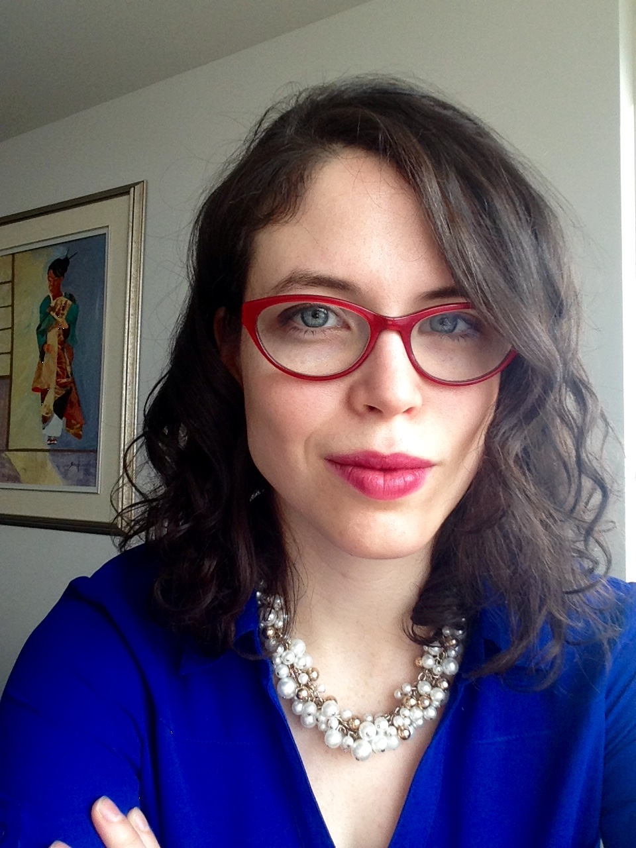

William H. Dutton, Quello Professor and Director of the Quello Center, Michigan State University @BiIIDutton

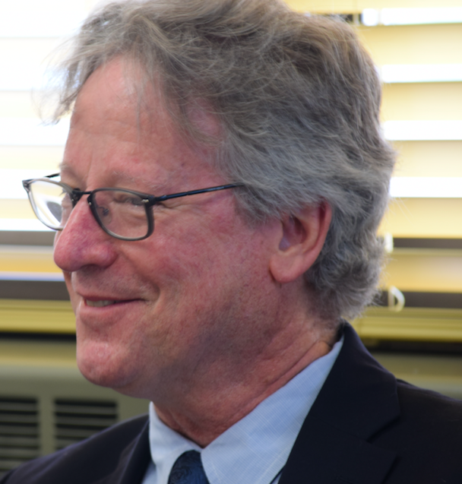

Ed Greenspon, President and CEO of the Public Policy Forum, Ottawa, Canada @egreenspon @ppforumca

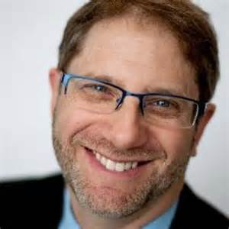

Anne Oeldorf-Hirsch, Assistant Professor, Department of Communication, Human-Computer Interaction Lab, University of Connecticut @anneohirsch‬‬‬‬‬‬

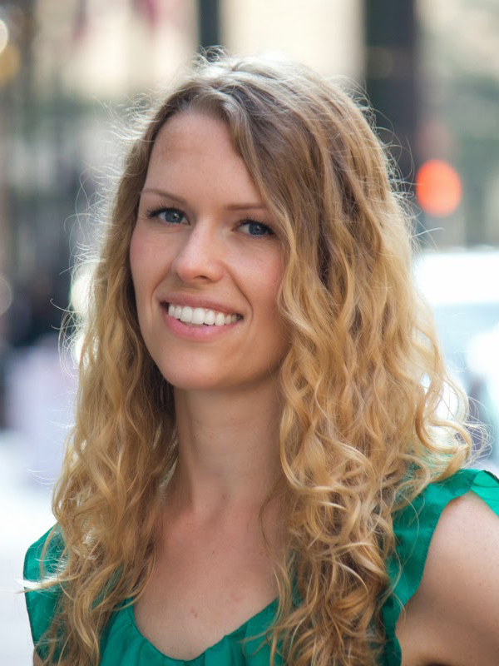

Craig Robertson, Doctoral Student, Media and Information, Michigan State University @CraigTRobertson

